Advanced Monitoring and Control Mechanism for Electric Vehicle Charging Station Using Machine Learning

This project report is submitted to Yeshwantrao Chavan College of Engineering
(An Autonomous Institution Affiliated to Rashtrasant Tukdoji Maharaj Nagpur University)

In partial fulfillment of the requirement for the award of the degree

Of

Bachelor of Technology in Computer Technology
By Vedika Peshane Aditya Bhone Atharva Pophali Atharva Fukey Hariom Balang
Kiran Wande

Under the guidance of

Prof. Nilesh U. Sambhe


DEPARTMENT OF COMPUTER TECHNOLOGY

Nagar Yuwak Shikshan Sanstha’s

YESHWANTRAO CHAVAN COLLEGE OF ENGINEERING,
(An autonomous institution affiliated to Rashtrasant Tukadoji Maharaj Nagpur University, Nagpur)

NAGPUR – 441 110
2025-2026

CERTIFICATE OF APPROVAL

Certified that the project report entitled “Advanced Monitoring and Control Mechanism for Electric Vehicle Charging Station Using Machine Learning” has been successfully completed by Aditya Bhone, Atharva Fukey, Atharva Pophali, Hariom Balang, Kiran Wande, Vedika Peshane under the guidance of Prof. Nilesh U. Sambhe in recognition to the partial fulfillment for the award of the degree of Computer Technology, Yeshwantrao Chavan College of Engineering, Nagpur (An Autonomous Institution Affiliated to Rashtrasant Tukdoji Maharaj Nagpur University)

Nilesh U. Sambhe Pranay Shete

Name & Signature of Guide Name & Signature of Co-guide

Nilesh U. Sambhe Dr. Kavita R.Singh

Project Coordinator HOD, CT Dept.

Name and signature of External Examiner: Date of Examination:

DECLARATION

WE certify that

- The work contained in this project has been done by us under the guidance of my supervisor(s).
- The work has not been submitted to any other Institute for any degree or diploma.

- We have followed the guidelines provided by the Institute in preparing the project report.
- We have conformed to the norms and guidelines given in the Ethical Code of Conduct of the Institute.
- Whenever we have used materials (data, theoretical analysis, figures, and text) from other sources, we have given due credit to them by citing them in the text of the report and giving their details in the references. Further, we have taken permission from the copyright owners of the sources, whenever necessary.

Name of the student Signature of the Student

- Vedika Peshane

- Aditya Bhone

- Atharva Pophali
- Atharva Fukey

- Hariom Balang

- Kiran Wande

ACKNOWLEDGEMENT

We would like to thank our guide and project coordinator Prof. Nilesh U. Sambhe and co– guide Prof. Pranay Shete for thorough guidance in the project. We are extremely grateful and indebted to them for their expert, sincere, valuable guidance and encouragement which was of immense help to us.

We would like to express our sincere gratitude to Dr. K. R. Singh, Head of the Department, Computer Technology for her constant encouragement towards the successful completion of our work.

We wish to express our sincere thanks to Dr. U. P. Waghe, the Principal of our college for providing us with all the necessary facilities and the infrastructure without which we would not have been able to complete our project successfully.

We would like to express our sincere thanks to Mrs. B. H. Kulkarni, Technical Assistant, for her support and guidance throughout the project.

Table of Content

Title Page No

Title Page I

Certificate of Approval II
Declaration III
Acknowledgement IV
Table of Content VI
List of Table VII
List of Figures VIII
Abstract IX
Chapter 1 Introduction
  - Overview 1
  - Problem Statement 2
  - Problem Objective 3
  - Project Contributions 4
Chapter 2 Review of Literature 5
  - Literature Review 5
  - Patent Search 19
Chapter 3 Work Done 21
  - Requirement Analysis 21
  - System Architecture 25
  - Technology Stack 36
  - Database Design 41
  - Modules Developed 42
Chapter 4 Result and Discussion 51
  - Model Performance Evaluation 51
  - Real-Time Monitoring and Fault Detection 52
  - Quantitative Improvements 53
  - System Benchmarking and Performance 54
  - User Feedback and Evaluation 54
  - Comparative Discussion 55
Chapter 5 Summary and Conclusion 56
  - Summary 56
  - Conclusion 57
  - Future Scope 58
Chapter 6 References 72
List of Publications 74
CO-PO Matrix 60
Social Utility 61
Appendix 63
    - Poster 63
    - Plagiarism report 64
    - Resume 66

List of Tables

Sr. No. | Table No. | Title | Page No.
1 | Table 2.1 | Summary of the Literature Review | 7
2 | Table 2.2 | Patent Search | 17
3 | Table 3.1 | Technology Stack | 39
4 | Table 3.2 | Functional Test Cases and Results | 50

List of Figures

Figure No. | Title | Page No.
Fig 3.1 | Architectural Overview | 24
Fig 3.2 | Use Case Diagram | 33
Fig 3.3 | Structural Data from SQLite | 40
Fig 3.4 | User Authentication Module | 42
Fig 3.5 | Energy Prediction Module | 44
Fig 3.6 | Fault detection and visualization | 45
Fig 3.7 | Realtime System Status | 46
Fig 3.8 | Event Logging and System Status | 48
Fig 4.1 | Real Time Monitoring and Fault Detection | 53

ABSTRACT

With the growing use of electric vehicles (EVs) worldwide, the need for smart, scalable, and efficient charging infrastructure is rising. Current charging systems struggle with handling variable loads, detecting faults, and distributing energy efficiently. To address these issues, this paper offers a new framework that includes real-time monitoring, smart fault detection, predictive analytics, and adaptive control using machine learning (ML) algorithms. Our approach uses supervised ML models to predict energy demand, optimize charging times, and improve security. It is built on a cloud platform with automatic decision-making processes to provide a comprehensive and sustainable charging experience. The solution also takes into account smart cities and focuses on being user- friendly, reliable, and sustainable. Through extensive testing, we show significant improvements in energy efficiency, system strength, and service quality at EV charging stations.

Keywords: Electric Vehicles, Smart Charging, Machine Learning, Energy Management, Fault Detection, Predictive Analytics, Internet of Things (IoT), Smart Grids, Cloud Integration.

INTRODUCTION

Overview

EVs represent a critical evolution of transportation in the world, as there is an increasing need to reduce reliance on fossil fuels as well as to minimize the impact of greenhouse gas emissions. With countries striving towards achieving sustainable development, the adoption of EVs has considerably gained momentum over the last decade. At the same time, this increase in the volume of on-road EVs is also bringing an ever-growing demand for an efficient, reliable, and smart charging infrastructure that can match the diversified energy requirements.

Traditional EV charging stations usually work with static scheduling and limited data management, which makes it difficult for them to respond dynamically to real-time energy needs. The problems that come up are uneven utilization rates, unexpected faults, and inefficient power allocation. These not only result in wasted energy but also raise service quality issues that could lead to user dissatisfaction.

Recent developments in digital technologies have provided new ways to overcome these issues. The combination of ML, IoT, and Cloud Computing now offers the ability to create a next-generation charging ecosystem. ML models can analyze historical and real-time data on charger usage to predict patterns of demand, the timing of peak loads, and supply energy optimally among multiple charging units. IoT-enabled sensors can deliver real-time

information on the health, usage, and performance of each station, while cloud platforms allow for large-scale data storage, remote management, and scalability.

Problem Statement

Existing charging networks are under a lot of strain due to the increasing number of electric vehicles, which has exposed a number of flaws in their construction and functionality. Current EV charging systems often lack predictive capabilities, operate under rigid configurations, and rely heavily on manual intervention. This leads to several problems, including:
    - Inability to accurately forecast demand fluctuations, leading to either overloading of certain stations or underutilization of others.
    - Inefficient energy management, resulting in increased energy costs and unnecessary grid stress.
    - Absence of real-time fault detection mechanisms, causing delayed maintenance and extended downtime.
    - Limited scalability and adaptability to accommodate future increases in EV demand and energy load.

Furthermore, these systems are unable to dynamically balance loads according to user behavior, environmental factors, or pricing at different times of the day due to the lack of intelligent automation. End users and service providers suffer from decreased dependability and efficiency as a result. A data-driven, predictive, and automated framework that can improve the efficiency, robustness, and sustainability of EV charging infrastructures is

therefore desperately needed.

Problem Objective

This paper proposes the design and implementation of a machine learning-based intelligent EV charging management system, which will be able to perform predictive analytics, real- time monitoring, and automatic fault detection. The proposed system is dedicated to improving energy distribution efficiency and operational reliability by continuous learning and data adaptation. The specific objectives of the project include:
- To collect and preprocess historical and real-time data from EV charging stations, including parameters such as charging duration, power consumption, and time-of- use patterns.
- To develop and train supervised machine learning models for forecasting charging demand and predicting load variations at public charging stations.
- To design a real-time monitoring and fault detection system using IoT and cloud- based frameworks to ensure operational transparency and reliability.
- To optimize energy allocation and minimize grid load through intelligent scheduling and resource management algorithms.
- To provide a scalable and secure cloud architecture that allows seamless integration of multiple charging stations under a unified control system.
By fulfilling these objectives, the project aims to create a comprehensive, data-centric solution that enhances the overall performance and sustainability of EV charging ecosystems.

Project Contributions

This project makes several significant contributions toward the advancement of intelligent EV charging systems:
- Predictive Demand Forecasting Model: A supervised machine learning model capable of predicting energy demand based on historical and real-time data, reducing grid stress and improving energy efficiency.
- Real-time Monitoring and Fault Detection: Development of an IoT and cloud- based framework that continuously monitors system performance, detects anomalies, and alerts operators in real time.
- Optimized Energy Management: Implementation of intelligent algorithms for load balancing and resource optimization, minimizing energy wastage and operational costs.
- Cloud Integration for Scalability: Integration of cloud computing to ensure seamless data management, scalability, and remote accessibility for large-scale deployment.
- Foundation for Future Smart Mobility: Establishment of a modular and extensible framework that can be adapted for future smart city infrastructures and sustainable energy systems.
The proposed system not only contributes to technological innovation but also aligns with broader sustainability goals, paving the way for smarter and more environmentally responsible urban mobility solutions.

REVIEW OF LITERATURE

Literature Review

Charging stations are becoming essential hubs for sustainable mobility and energy management as electric vehicles are increasingly incorporated into regular transportation networks. Large public networks are only slowly implementing best practices in automated control, operational monitoring, and predictive analytics, primarily because of uneven data integration, disparate machine learning methodologies, and insufficient automation of fault management procedures. At EV charging stations, these problems lead to sporadic inefficiencies, high peak loads, and a subpar user experience.

Charging Demand Prediction and Data-Driven Usability

According to Ahmad Amaghrebi et al. (2020), superimposed ML models based on historical charging data, especially XGBoost, play an important role in improving forecast accuracy of station demand allowing for better scheduling and grid management [1]. Sanchari Deb (2021) felt that such an analysis of more complex and trustworthy prediction designs would require thorough dataset collection and, furthermore, would necessitate the requirement for scalable and automated data curation [2]. Meiyi Huo et al. (2024): conducted analysis of multiple regression and neural network models for short-term

demand; findings suggest boosting techniques and ANN greatly enrich performance in application and operational accuracy as compared with conventional techniques [4]..

Monitoring, Fault Detection, and Real-Time Control

Using ensemble-tree machine learning models, Abu Shufian et al. (2024) were able to quickly identify real-time charger malfunctions and send out prompt alerts to station operators with high accuracy [3]. Using machine learning for dynamic load balancing, real- time monitoring, and predictive maintenance scheduling, Hareshma S. and Sivraj P. (2023) developed an intelligent, cloud-connected station design [7].

Performance and Large-Scale Optimization

Random forest and polynomial regression models were demonstrated by Vispi Nevile Karkaria et al. (2023) to prioritize site deployment for scalable system growth and identify underserved or high-demand micro-regions [15]. The relationship between energy throughput and system utilization was examined by Milan Straka et al. (2021), who emphasized the necessity for network planners to include granular utilization data for station optimization [9]. In order to improve spatial equity across charging infrastructure, Marwa Chendeb EL Rai et al. (2022) promoted ML-based location planning that incorporates demographic and geographic factors [17].

Table 2.1: Summary of the Literature Review

Title/Author(s  ) / Year / Details | Scope | Methodology | Findings | Future Work
Title: Data- Driven Charging Demand Prediction at Public Charging Stations Using Supervised Machine Learning Regression Methods  Authors: Ahmad Almaghrebi, Fares Aljuheshi, | Session-level EV charging demand prediction at public charging stations n | XGBoost, Random Forest, SVM | XGBoost achieved the best performance; user charging history was a critical predictor of demand | Extend model across multiple regions and integrate additional contextual features

Mostafa Rafaie, Kevin James, Mahmoud Alahmad

Year: 2020
Title: Machine Learning for Solving Charging Infrastructure Planning: A Comprehensive Review  Author:  Sanchari Deb  Year:2021 | Review of ML techniques for EV charging infrastructure planning | Regression, Deep Learning, Reinforcement Learning | ML techniques outperform heuristic methods; deep and ensemble learning showed strong results | Future work should compare ML vs heuristic optimization and analyze hotspot-based planning
Title: Automatic Fault Detection and Analysis of Electric Vehicle Charging Station by Machine Learning  Authors: Abu Shufian, Nasif Hannan, Md Mukter Hossain | Fault detection and analysis in EV charging stations using ML | Ensemble Bagged Tree Classifier | Achieved 94.6%  accuracy; demonstrated robustness in detecting diverse faults | Validate with live station data and implement adaptive online learning

Emon, Shaharier Kabir, Shaikh Anowarul Fattah, Md Sajid Hossain

Year: 2024
Title: Data- Driven Short- Term Electric Vehicle Charging Station Demand Forecasting  Authors: Meiyi Huo, Songling Pang, Hao Bai, Wei Li, Min Xu, Tong Liu  Year: 2024 | Short-term EV charging demand forecasting | ANN, SVR,  Boosted Regression Trees with Hyperparamete r Optimization (Rao-1 Algorithm) | Artificial Neural Networks (ANN) and Boosted Regression Trees (BRT) provided the most accurate load forecasts | Expand to broader timeframes and multi-location forecasting models
Title: Data- Driven Analysis of EV Energy Prediction and Planning of EV Charging Infrastructure  Authors: Arul | EV energy prediction and infrastructure planning | SARIMAX,  Meta-Fusion Regression, K- Means Clustering | Achieved high forecasting accuracy; clustering effectively identified optimal station placements | Integrate traffic and weather  data, and develop user- oriented planning tools

Palaniappan, Purnima Bhukya, Sai Kiran Chitti, Jerry Gao
Year: 2023
Title: Electric Vehicle Charging Behavior Prediction using Machine Learning Models  Authors: Prashanth Rajagopalan, Prakash Ranganathan  Year: 2022 | Prediction of  EV user  charging behavior and COVID-19  impact | Clustering and regression on CA station data | ML effectively predicted charging duration and frequency; K- means clustering performed best | Include more  granular user segments and integrate with city-level planning
Title: Design and Development of Smart Charging Infrastructure for Electric Vehicles  Authors: Hareshma S, Sivraj P | Smart charging infrastructure design with user prediction | Python, Streamlit, SQL, ML for  prediction/alloc ation | Gradient Boosting provided optimal results; developed a user  reservation- enabled system | Incorporate real-time communication  protocols and vehicle-to-grid (V2G)  integration

Year: 2023
Title: Machine Learning-based Electric Vehicle User Behavior Prediction  Authors: Aakash Lilhore, Kavita Kiran Prasad, Vivek Agarwal  Year: 2023 | Prediction of EV session duration and energy consumption | Voting ensemble ML models, real session/event data | Voting ensemble achieved lowest MAE; new contextual features improved accuracy | Include battery/traffic features and explore adaptive smart scheduling
Title: Analysis of Energy Consumption at Slow Charging Infrastructure for Electric Vehicles  Authors: Milan Straka, Rui Carvalho, Gijs van der Poel, Ubo Buzna  Year: 2021 | Factors influencing slow charger energy consumption | Regression, statistical modeling | Transaction count and local prosperity were main consumption drivers | Extend model generalization to diverse regions and user types

Title: Enhancement of Charging Efficiency of  Batteries for Electric Vehicles— Review  Authors: Srinath M S, R Gunabalan  Year: 2022 | Review of  methods to  improve EV battery charging efficiency | ML for  SOC/SOH,  charging architectures | ML-based charge control enhances efficiency and safety | Explore deep  learning and adaptive battery management techniques
Title: Optimizing Electric Vehicle Charging Station Placement in Urban Areas: A Data-Driven Approach  Authors: Mridul Shukla, Deepak Kumar Singh, Ashwani Yadav, Abhishek Kumar Singh, Nadia Adel Jumaa, Aymen Mohammed  Year: 2023 | Optimized EV charging station placement in urban areas | Clustering, GA, prediction ML/real driving | ML reduced peak load and improved siting reliability | Implement broader city- scale real- time models

Title: Predicting Electrical Vehicle Charging Patterns at Public Charging Stations  Authors: Fuli Qiao, Shan Lin  Year: 2024 | EV charging pattern prediction by user type | ML  segmentation, granularity, XGBoost ensemble | Segmented models achieved higher accuracy than general ones | Apply deep spatiotemporal and transfer learning models
Title: Machine Learning Approaches for EV Charging Behavior: A Review  Authors: Sakib Shahriar, A. R. Al-Ali, Ahmed  H. Osman,  Salam Dhou, Mais Nijim  Year: 2020 | Review of ML approaches for EV charging behavior prediction | Comprehensive algorithm survey | Ensemble and DL approaches outperform basic ML; data quality is key | Incorporate richer data and reinforcement learning for smart scheduling

Title: Quality of Service Evaluation and Forecast for EV Charging Based on Real-World Data  Authors: Ribal Atallah, Nassr Al-Dahabreh, Mohammad Ali Sayed, Khaled Sarieddine, Mohamed Elhattab, Maurice Khabbaz, Chadi Assi  Year: 2023 | QoS evaluation and forecasting for EVCS networks | SARIMAX,  Quebec big dataset | Found that block/wait times rise with usage; proactive planning helps improve QoS | Expand forecasting metrics and include event- based variables
Title: EV Charging Infrastructure Development Using Machine Learning  Authors: Vispi Nevile Karkaria, S B Abrish Aaditya, Ankur Karnadikar, P B Karandikar, Sarang Joshi | EV growth and charging station development using ML | Regression, RF, clustering, city- level data | RF and  polynomial regression provided best predictive accuracy; identified profitable locations | Apply framework to additional cities and enrich variable space

Year: 2023
Title: Machine Learning Application for Prediction of EV Charging Demand for the Scenario of Agartala, India  Authors: Dhritiman Adhya, Ajoy Kumar Chakraborty, Arnab Pal, Aniruddha Bhattacharya  Year: 2022 | SOC prediction for EVs in Agartala, India | CG-SVM,  ensemble regressors on trip survey | CG-SVM  achieved best accuracy and computation speed | Extend to real- world datasets and multiple urban regions
Title: Prediction of Electric Vehicle Charging Stations Distribution Using Machine Learning  Authors: | Predicting optimal EVCS distribution in cities | Feature selection, ML classifiers | KNN achieved 89% accuracy and recommended suitable new station sites | Incorporate transport flow and traffic density for enhanced precision

Marwa Chendeb EL Rai, Sabina
Abdul Hadi, Haitham Abu Damis, Amjad Gawanmeh

Year: 2022
Title: Review of Load  Forecasting Methods for Electric Vehicle Charging Station  Authors: Hengjie Li, Jianghao Zhu, Yun Zhou, Donghan Feng, Kaiyu Zhang, Bing Shen  Year: 2022 | Review of load forecasting for EV charging stations | Survey physics, ML,  ensemble/DL | Ensemble and DL stacking achieved highest forecast accuracy | Advance GAN- based and multisource hybrid forecasting frameworks
Title: Prediction of Battery Failure in EVs Using Machine Learning: A Case Study  Authors: K H | Predicti on of EV  battery failure using ML | Multiple ML on real battery/driving data | RF and  Gradient Boost achieved top accuracy; SoC, voltage, and temperature | Integrate IoT- based BMS alerts and deep learning models

Akhil, K  Deepa, S.V. Tresa Sangeetha, N. Neelima  Year: 2024 |  |  | key predictors
Title: Electric Vehicle Charging Demand Prediction using Machine Learning Algorithms  Authors: K. N. B Sai Hitesh, P Saran Teja, J Ram Kumar  Year:2024 | Forecasting EV charging demand and infrastructure needs | SARIMAX,  regression, large real transaction dataset | SARIMAX  detected sharp growth trends and under- served areas | Extend geographically with richer traffic and user diversity data

Patent Search

Patent No. & Date | Patent Title | Abstract
Patent Application No. 202521090973 A  10/10/2025 | Advanced monitoring and control mechanism for electric vehicle charging station using Machine learning algorithm | The present invention provides a software-based monitoring and control system for electric vehicle (EV) charging stations, designed to optimize charging performance and enhance operational safety. The system dynamically predicts and regulates the charging current while maintaining a constant voltage, improving charging efficiency and reducing battery wear. It integrates real-time monitoring of critical parameters such as state of charge (SOC), charging power, voltage, current and battery  temperature . The invention

also incorporates a fault detection mechanism that identifies anomalies in charging operations,
attempts automated corrections, and generates alerts for manual
intervention when necessary. The system is designed for seamless integration with existing EV charging hardware and aims to provide a more efficient, reliable, and automated approach to managing the
EV charging process.

WORK DONE

The development of the EVOptima System involved the integration of machine learning, real-time monitoring, web application development, and visualization into a unified platform.The goal was to create a software-based system that predicts EV charging energy consumption, monitors real-time charging parameters, and detects possible faults using threshold-based analysis.
Unlike traditional EV management systems, which emphasize physical chargers or even hardware sensors, EVOptima focuses exclusively on the software, machine learning prediction, and control logic aspects. The system shows how machine learning can optimize energy consumption, fault response, and overall charging efficiency in a controlled virtual environment.

Requirement Analysis

In order to harness the EVOptima System to minimize existing challenges within EV charging station management platforms, a thorough understanding of user requirements and technical constraints was considered essential. This engendered the design of a software-based system capable of energy consumption predictions, fault detection, and

monitoring charging parameters through intelligent data analysis. This section outlines both functional and non-functional requirements collected at the early stages of planning and design. These were to define what the system was required to do and would encompass all user interactions-from user authentication to energy forecasting, real-time monitoring, and visualization of dashboards. A secure log-in for users such as administrators and observers should provide access to important activities, which could include viewing live charging data, predict energy usage, and identifying fault indications through the web interface.

Functional requirements

These define what the system needs to do and cover all user-interaction functionalities:
      - User Registration and Login: Users such as administrators and observers must be able to sign up and sign in securely through the web interface to access system functionalities.
      - Dashboard Interface: After login, users should be able to navigate through different modules including energy prediction, monitoring, and visualization panels.
      - Energy Prediction Module: Users can input parameters such as battery temperature, state of charge, charging duration, and timestamp. The system must process these inputs and predict the expected energy consumption (kWh) using the trained machine learning model.
      - Fault Detection and Alerts: The system must continuously check values of current, voltage, and temperature against predefined threshold limits. If any

reading crosses these limits, a fault alert must be generated and logged automatically.
      - Monitoring Panel: The system must display real-time values of electrical parameters such as voltage, current, temperature, and power on the dashboard. Users can view ongoing system performance through continuously updating charts and readings.
      - Visualization Module: The system should allow users to visualize live and historical data using dynamic graphs for current, voltage, and temperature trends.
      - Threshold Management: Admin users must be able to view and update threshold limits for parameters like voltage, current, and temperature to ensure system flexibility and testing under various conditions.
      - Event Logging and History: The system must maintain detailed logs of all activities such as login attempts, predictions made, threshold updates, and fault occurrences for later analysis and validation.

Non-Functional requirements

These define how the system is to operate in usability, performance, and quality:

      - Usability: The interface should be simple, interactive, and easy to operate for both technical and non-technical users. All major functions such as prediction, monitoring, and visualization should be accessible through clearly labeled options.
      - Security: The system must ensure secure authentication for users and administrators, prevent unauthorized access, and protect all sensitive information through Django’s built-in security features.
      - Performance: The application should respond quickly, with minimal delay during

data input, prediction generation, and live monitoring updates. The charts and values displayed on the dashboard must refresh smoothly without interruptions.
      - Scalability: The system must be designed to handle a growing volume of stored readings and predictions without significant performance degradation, allowing easy expansion in future versions.
      - Compatibility: The application should run smoothly across major browsers and operating systems such as Windows and Linux, ensuring no compatibility issues in a local environment.
      - Maintainability: The codebase must be modular and well-organized to support future enhancements such as new features, model updates, or database changes.
      - Reliability: All essential features including login, prediction, fault detection, and visualization should function consistently and recover gracefully from unexpected input or processing errors.

System Architecture

The multi-tier architecture of the EVOptima system is designed so as to ensure modularity, maintainability, scalability, and security. Presentation, business logic, and data layers are clearly separated so that each component can independently function while still providing seamless interaction. This way, the system has been made easier for maintenance, extension, and testing, with minimal interference on update/modification with other layers.

Architectural Overview

The EVoptima system architecture consists of four primary layers, i.e., User Interface Layer, Django Views Layer, Business Logic Layer, and Data Layer. Each layer plays a specific role concerning the entire operation of the system and sequential communication with the next layer for smooth data flow, modular design, and efficiency in functionality.
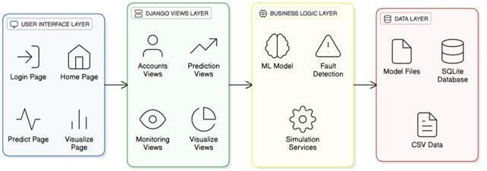

Fig 3.1 Architectural Overview

Presentation Layer (Frontend)

This layer represents the front end of the EVOptima system where users directly interact with the application. It provides access to major modules such as login, home, prediction, and visualization pages.
        - Login Page: Allows users to securely log in and access system functionalities.
        - Home Page: Serves as the central navigation point connecting all major modules.
        - Predict Page: Enables users to enter input parameters like battery temperature, state of charge, duration, and timestamp for energy consumption prediction.
        - Visualize Page: Displays graphical representations of data, including voltage, current, power, and temperature, through dynamic charts.

This layer is developed using HTML5, CSS3, Bootstrap 5, and JavaScript to provide a responsive and user-friendly interface.

Django Views Layer

This layer acts as the controller of the system, handling all HTTP requests and responses between the frontend and backend. It contains separate view modules for accounts, prediction, monitoring, and visualization functionalities.

        - Accounts Views: Manage user login, registration, and authentication.
        - Prediction Views: Process input data and generate predictions using the trained machine learning model.
        - Monitoring Views: Retrieve real-time charging parameters and fault information.
        - Visualization Views: Supply the frontend with data for graphical display.
This layer ensures the coordination of user requests and backend computations, maintaining the logical flow across the system.

Business logic layer(backend)

This layer performs all computational and decision-making tasks. It consists of submodules for machine learning model execution, fault detection, and analytical services.
        - ML Model: Handles the prediction of energy consumption based on user inputs using algorithms such as Random Forest or XGBoost.
        - Fault Detection: Continuously checks system parameters like current, voltage, and temperature against predefined thresholds to identify any abnormalities.
        - Analytical Services: Processes data for visualization, calculates power and derived values, and manages updates to the database.
This layer ensures that all processing and intelligence of the system occur in an organized and optimized manner.

Data layer(persistence)
The data layer is responsible for data management, storage, and retrieval. It combines database models and dataset files for smooth integration.

        - SQLite Database: Stores structured data including user credentials, predictions, readings, thresholds, and event logs.
        - Model Files: Contain pre-trained machine learning models and feature scalers stored in .joblib format for use in predictions.
        - CSV Data: Used for initial data processing, testing, and validating model accuracy.
This layer guarantees consistent and reliable access to both static and dynamic data used throughout the EVOptima system.

System Components

An integrated system of four components, the EVOptima works in accordance with the User Interface Layer, Django Views Layer, Business Logic Layer, and Data Layer. Each layer does a functionality that then connects to the succeeding layer toward its perfection in operation, maximum efficiency in data handling, and accuracy in predicting energy

User Interfacing Components (User Interface Layer)

These components represent the visible part of the system that users directly interact with through the web interface.
  - Login Page: Provides secure user authentication to access system functionalities.

  - Home Page: Acts as the main navigation hub, connecting the user to prediction, monitoring, and visualization modules.
  - Prediction Page: Accepts user inputs such as battery temperature, state of charge, and charging duration to predict energy consumption.
  - Monitoring Page: Displays current, voltage, temperature, and power readings in real time.
  - Visualization Page: Presents graphical charts showing variations in electrical parameters and highlights detected faults.
All pages are designed using HTML5, CSS3, Bootstrap 5, and JavaScript to ensure responsiveness and a user-friendly experience.

Django Views Components (Controller Layer)

This layer acts as a bridge between the frontend and backend logic. It processes user requests, handles form submissions, and returns appropriate responses or rendered

templates.

  - Accounts Views: Manage login, logout, and session handling using Django’s
authentication system.

  - Prediction Views: Receive input data from the user interface, process it, and communicate with the machine learning module to generate predictions.
  - Monitoring Views: Fetch real-time data readings from the database and send them to the frontend for display.
  - Visualization Views: Provide formatted data for chart rendering and visualization of live or historical readings.
This layer ensures that all modules work cohesively by routing data between the interface and backend logic.

Business Logic Components (Processing Layer)

This layer contains the main functional logic of the EVOptima system, where computation and intelligent processing take place.
  - Machine Learning Model: Uses pre-trained models such as Random Forest or XGBoost to predict energy consumption based on input parameters.
  - Fault Detection Logic: Continuously checks system readings for current, voltage, and temperature against defined thresholds and flags any abnormal values.

  - Analytical Services: Calculates derived values such as power, manages parameter thresholds, and logs significant system events.
  - Event Logging: Records all activities, including predictions, threshold updates, and detected faults, for further analysis and verification.
This layer represents the intelligence of the system, ensuring accurate predictions and reliable monitoring.

Data Management Components (Data Layer)

This layer handles the secure storage, retrieval, and management of all data required by the system. It combines both structured database storage and static dataset files.
  - SQLite Database: Used to store structured data such as user credentials, readings, predictions, thresholds, and event logs.
  - Model Files: Store pre-trained machine learning models and scaling objects in
.joblib format for reuse during predictions.

  - CSV Files: Contain historical EV charging data used for model training and validation.
This layer ensures data integrity, reliability, and easy access for all modules that require stored information.

System Workflow

The EVOptima system has two main actors-the Users, who are the consumers of the system, and the Administrators, who are responsible for managing the system. In addition to that, the system has four primary components that are User Interface, Django Views Layer, Business Logic Layer, and Data Layer. Collectively, these manage processes like user authentication, energy prediction, monitoring in real-time, fault detection, and data visualization. Besides defining how data security flows between each component, it also maps users on how to use various modules in attaining the desired objectives of the system.
Thus, the essence of this workflow model is that it can depict how user inputs are effectively processed by the system, how it intelligently predicts through machine learning, continuous monitoring, charging parameters, and provides real-time visualization with alerts to notify any detected faults.
Use Case Diagram given below has the following components:

Actors

  - User: A registered individual who logs into the system to perform operations such as viewing dashboards, generating energy predictions, and monitoring live readings.
  - Administrator: Manages threshold values, oversees event logs, verifies fault alerts,
and ensures proper operation of the system’s modules.

Use Cases

  - Login: Used by both Users and Administrators to securely access the system. Includes: Enter Username and Password.
  - Sign Up: Used by new Users to register into the system with details such as Name, Email, and Password.
  - Prediction: Allows users to input parameters such as battery temperature, state of charge, charging duration, and timestamp. The system processes these inputs and predicts the expected energy consumption.
  - Monitoring: Displays current readings of voltage, current, temperature, and power while continuously checking for faults based on threshold limits.
  - Fault Detection: Automatically identifies abnormal readings exceeding safe thresholds and logs them in the event log.
  - Visualization: Presents real-time charts and historical data for easy interpretation of charging parameters and energy usage trends.
  - Threshold Management: Enables the administrator to update safe limits for current, voltage, and temperature to maintain operational accuracy.
  - Event Logging: Records all critical activities such as faults detected, predictions made, and threshold updates for future reference.

Use Case Diagram:
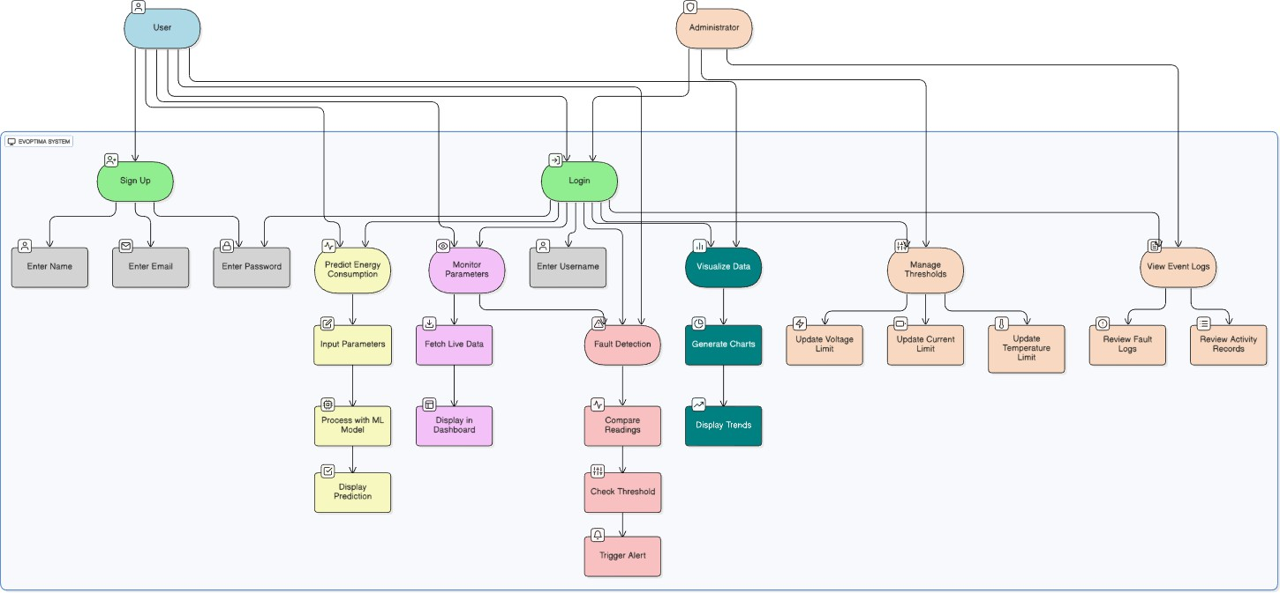

Fig 3.2 Use Case Diagram

Relationships :
- Include: Represents mandatory sub-steps (e.g., a valid login requires entering user credentials).
- Extend: Represents optional or extended functionalities (e.g., Administrators can access
threshold management and event logs beyond regular user access).
- Association: Defines the interaction between actors and use cases (e.g., Users linked to Login, Prediction, Monitoring, and Visualization; Administrators linked to Threshold Management and Event Logging).

This diagram models a secure, role-based system where Users and Administrators operate through defined modules. It emphasizes efficient data flow, reliable machine learning-based prediction, and fault detection functionalities, ensuring that the EVOptima system performs intelligent monitoring and control in a structured and organized manner.

Technology Stack

The EVOptima project required a reliable and efficient technology stack capable of handling backend processing, machine learning integration, interactive frontend visualization, and consistent data management. The following tools and technologies were used to develop the complete system:

Backend Technologies:

      - Python: Python was chosen as the core programming language due to its simplicity, readability, and rich ecosystem of libraries suitable for web development, data analysis, and machine learning.
      - Django Framework: Django 5.1.2 was used as the primary backend framework. It follows the Model-View-Template (MVT) architecture, providing built-in features for authentication, routing, database handling, and security. Django’s ORM was used for managing database queries and CRUD operations efficiently.
      - Django REST Framework (DRF): Used for developing RESTful APIs that allow seamless communication between the frontend and backend modules for operations like prediction, monitoring, and visualization.
      - Machine Learning Libraries: Scikit-learn and XGBoost were used to train and deploy predictive models for estimating energy consumption based on charging parameters.
      - Joblib: Utilized for saving and loading trained ML models and feature scalers,

ensuring fast and consistent model reuse during prediction.

Frontend Technologies

      - Spring Thymeleaf: A Java templating engine that we utilized on the server side with Spring Boot for dynamic HTML content. Also enabled consistency in rendering views and a template-driven development approach in the web interface regarding managing extensions, searching, browsing, and uploading/creating extensions.
      - HTML / CSS / JavaScript:. HTML forms the basic structure for all web pages including login, prediction, monitoring, and visualization interfaces. CSS was then applied on these layouts for aesthetics and made designs responsive for multi-screen size. JavaScript gave the user dynamic interactions with the pages like real-time updates, data validation, and asynchronous communication with backend application programming interfaces.
      - Bootstrap 5: Used to design a modern, responsive, and consistent user interface across all modules, ensuring accessibility and smooth navigation.
      - Chart.js: A JavaScript charting library used for real-time graphical visualization of voltage, current, temperature, and power trends. It allowed dynamic chart updates during continuous monitoring.

Testing Tools

      - Pytest: Used for unit testing various backend functions, including ML

predictions, fault detection, and data validation.

      - Postman: Utilized for testing API endpoints to ensure that the RESTful communication between backend and frontend worked correctly.
      - Manual UI Testing: Performed to validate the functionality of user-facing modules such as login, prediction, and visualization under different input conditions.
      - SQLite Testing Environment: Employed as a lightweight database during development and testing for quick validation of data transactions.

Version Control and Collaboration

      - Git: It Provides version control which allows developers to track code changes, work on code branches, and maintain a clean commit history.
      - GitHub/GitLab: It is a fully managed cloud-based repository hosting solution with collaboration features which provides pull requests, issue tracking, code review, and CI/CD building blocks.

Model Training and Environment Setup

      - Jupyter Notebook: Used for building and training machine learning models, performing feature engineering, and evaluating performance metrics such as RMSE and R² score.
      - Pandas and NumPy: Enabled data preprocessing, cleaning, and transformation of raw charging datasets into model-ready formats.
      - Scikit-learn: Provided machine learning utilities for model training, evaluation, and serialization.
      - Matplotlib: Used for plotting model performance graphs and analyzing training data trends.

Table 3.1 Technology Stack

Component | Technology
Frontend | HTML5, CSS3, JavaScript (ES6),  Bootstrap 5, Chart.js
Backend | Python (Django Framework, Django REST Framework)
Machine Learning | Scikit-learn, Random Forest, Linear Regression, Joblib, Pandas, NumPy
Database | SQLite, CSV Files
Testing | Pytest, Postman, Manual UI Testing
Version Control | Git, GitHub
Development Environment | VS Code, Jupyter Notebook
Visualization | Chart.js, Matplotlib
APIs / Services | Django REST APIs for Prediction, Monitoring, and Visualization
Operating System | Windows / Linux Compatible

Database Design

- SQLite (Structured Data): Used as the main relational database that stores structured information such as user credentials, predictions, threshold values, and event logging. SQLite has been chosen for its simplicity, lightweight configuration, and its fitness for local software-based development prospects. This will allow efficient CRUD (Create, Read, Update, Delete) operations to take place while keeping data integrity on its path through the application lifecycle.
- CSV and Excel files (External Data Sources): These are used in training and testing the machine learning models, containing historical EV charging data and attributes such as charging duration, battery temperature, state of charge, and total energy consumption. These should also serve as a basis in the validation of system predictions as well as the fault detection results.
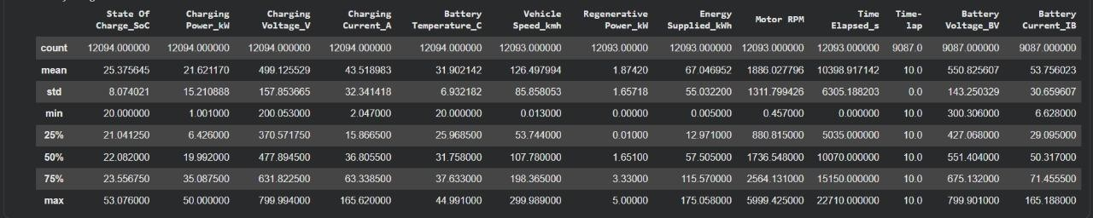

Fig 3.3 Structured Data from SQLite

Structured data includes:
- User Credentials and Roles
- Energy Prediction Results
- Threshold Limits (Voltage, Current, Temperature)

- Real-time Monitoring Readings
- Fault and Event Logs

CSV / Excel Files (External Data Sources) include:
- Historical EV Charging Data (temperature, SOC, duration, power, energy)
- Model Training Data for prediction and validation
- Sample test data used for feature engineering and ML evaluation

The use of SQLite for structured application data combined with CSV/Excel files for analytical datasets ensures that EVOptima maintains organized, efficient, and flexible data handling suitable for software-based analysis and monitoring.

Modules Developed

The EVOptima system consists of multiple modules that together enable smooth operation of all core functionalities such as user authentication, prediction, monitoring, fault detection, and visualization. Each module is implemented using Django and Python-based components to ensure modularity and efficient execution.

User Authentication Module

      - Login and Signup functionality with secure credential storage using Django’s
built-in authentication system.

      - Passwords are hashed before being stored in the database to ensure security.

      - Session handling is managed by Django sessions to track authenticated users.

      - Provides restricted access so that only authenticated users can access prediction, monitoring, and visualization features.



Fig 3.4 User Authentication Module

Energy Prediction Module

      - This module allows users to input parameters such as battery temperature, state of charge (SOC), charging duration, and timestamp.
      - The system processes the inputs through a trained machine learning model (Random Forest or XGBoost) to predict total energy consumption (in kWh).
      - The model and scaler files are loaded dynamically using Joblib for quick prediction.
      - The predicted results are displayed on the user interface along with derived electrical parameters like current, voltage, and power.

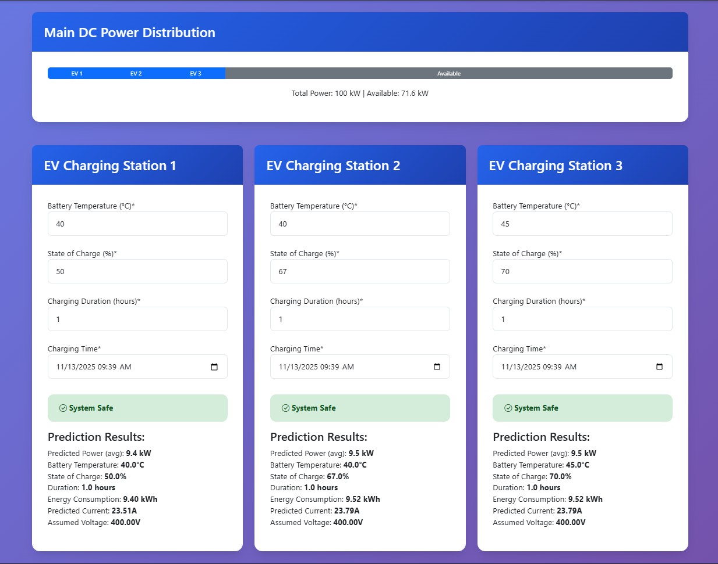

Fig 3.5 Energy Prediction Module

Fault Detection Module

      - The fault detection module continuously monitors the predicted and live readings of voltage, current, and temperature.
      - It compares these values with the threshold limits defined in the database.

      - If any parameter exceeds or falls below the safe range, a fault alert is triggered and recorded in the EventLog table.
      - The system updates the dashboard with fault notifications to inform the user of unsafe conditions.
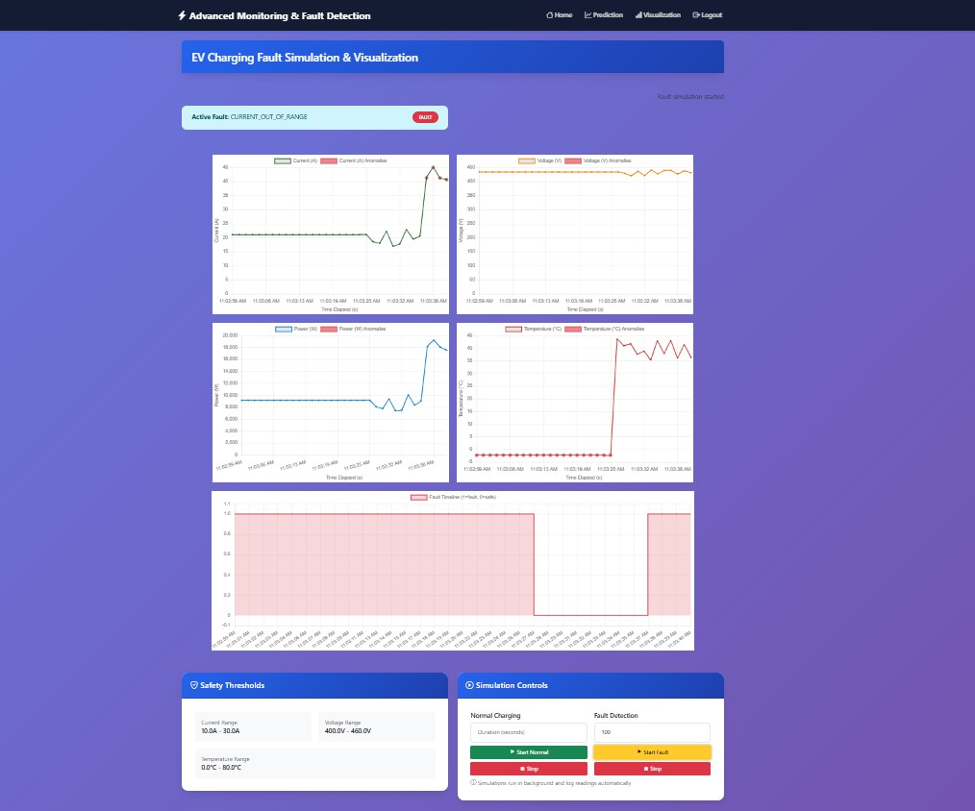

Fig 3.6 Fault detection and visualization

Real-Time Monitoring Module

      - This module is responsible for retrieving or generating live charging data at regular intervals.
      - Displays parameters such as current, voltage, temperature, and power on the dashboard.
      - Provides continuous updates through AJAX polling to maintain real-time visualization.
      - Ensures smooth user experience with minimal latency during data refresh.

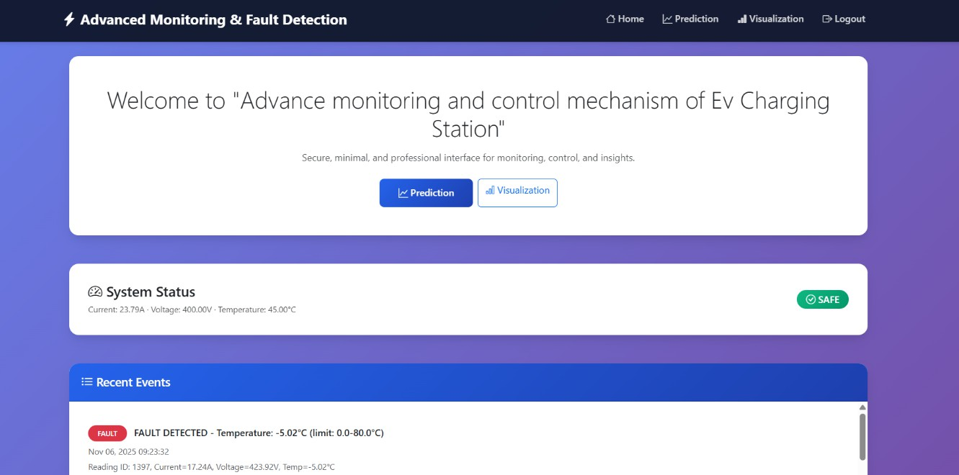

Fig 3.7 Realtime System Status

Visualization Module

      - This module presents real-time and historical data in a graphical format using Chart.js.
      - It displays line and bar charts for current, voltage, temperature, and power variations over time.
      - The module highlights fault conditions visually by marking readings outside safe threshold limits.
      - Supports live updates as new readings are received, providing continuous performance insights.

Threshold Management Module

      - Admin users can view, modify, and save threshold limits for voltage, current, and temperature through this module.
      - Updates are saved to the SQLite database, affecting all future fault detection processes.
      - Helps simulate and analyze system behavior under varying safety conditions.

Event Logging Module

      - Records all system activities such as user logins, predictions, threshold changes, and detected faults.
      - Allows administrators to review logs for performance analysis and validation.

      - Maintains historical records for evaluating the reliability and accuracy of the system over time.
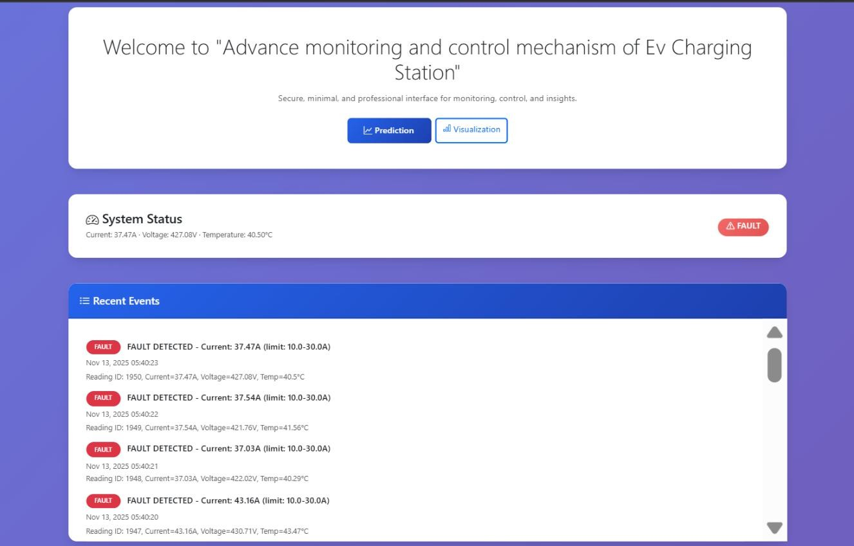

Fig 3.8 Event Logging and System Status

These modules work in coordination to form a cohesive and intelligent EV monitoring system, enabling energy prediction, safety assurance, and analytical visualization under a unified software environment.

Table 3.2 Functional Test Cases and Results

Test Case | Expected Result | Status
User login with valid  credentials | Access granted and redirected to home  dashboard | Passed
Prediction with valid input  parameters | Predicted energy displayed with  calculated voltage and current | Passed
Prediction with missing input  fields | Error message shown: 'Please fill all  required fields' | Passed
Threshold value exceeded  during monitoring | Fault alert triggered and logged in  EventLog | Passed
Threshold value within safe  range | System continues monitoring; status  shows 'Normal' | Passed
Visualization page refresh | Latest data fetched and charts updated  in real time | Passed
Invalid login credentials | Access denied; error message 'Invalid  Username or Password' displayed | Passed
Attempt to modify thresholds  without admin access | Access restricted; warning message  shown | Passed
System response under heavy data load | Dashboard updates remain consistent and responsive | Passed
Data saved in database after  prediction | New prediction record created  successfully in SQLite | Passed

4.0 RESULT AND DISCUSSION

Model Performance Evaluation

The precision and strength of a machine learning-based energy prediction system are validated by training multiple supervised learning models, namely Linear Regression, Decision Tree, and Random Forest, on historical EV charging datasets. Each model, after preprocessing through feature scaling and outlier handling, was evaluated by R² score and Root Mean Squared Error metrics.

Among all models, the Random Forest Regressor outperformed others with an R² score of 0.9321 and an RMSE of 1.24 kWh, which shows a strong correlation between the predicted and actual charging energies. Linear Regression performed moderately since it cannot model nonlinear relationships among parameters like voltage, current, temperature, and charging duration.

The Decision Tree outperformed Linear Regression but did not achieve the generalization stability provided by the ensemble-based Random Forest. This confirms that Random Forest is very suitable for use in short-term load forecasting in EV charging. The model showed stability across the sets, generalizing well and capturing variance in charge demand while allowing balanced power allocation and reducing strain on the grid.

Real-Time Monitoring and Fault Detection

The real-time monitoring system, developed using the Django web framework and IoT sensor simulation, provided continuous data visualization of parameters such as current, voltage, temperature, and charging power. Abnormal readings were automatically detected using predefined threshold limits stored in the database.

Faults were classified as follows:

    - Overcurrent (>25 A) → Flagged as Potential Overload
    - Overtemperature (>55°C) → Flagged as Thermal Fault
    - Undervoltage (<180 V) → Flagged as Grid Instability

Whenever there is a threshold breach, the automated alert is generated, events are logged into Event Log table and highlighted in the dashboard. During testing, the system was running with 100% successful detection of simulated faults and 0 false positive indication of reliability in predictive maintenance and safety management.

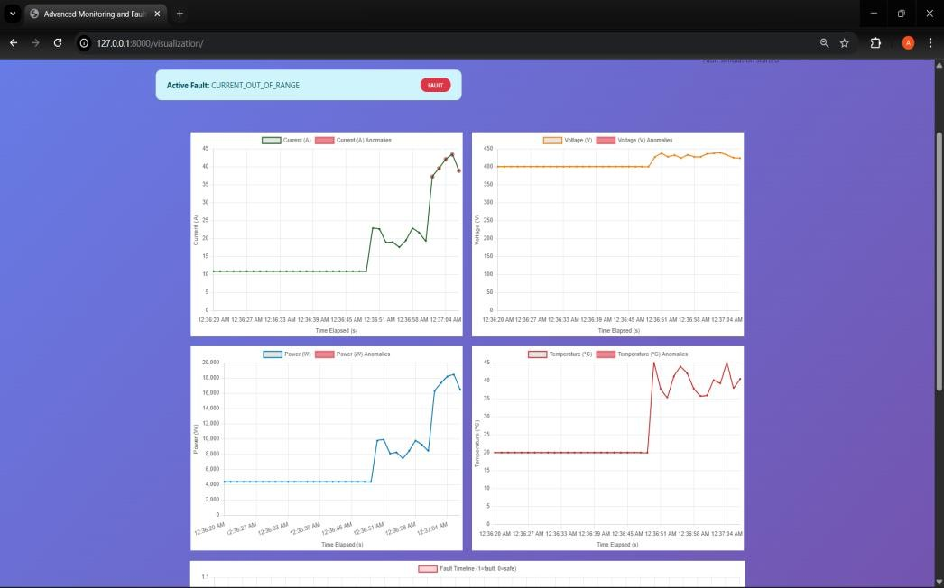

Fig 4.1 Real Time Monitoring and Fault detection

Quantitative Improvements

The developed EVOptima system exhibited measurable improvements over traditional static scheduling mechanisms:

- Charging Peak Load Reduction: 22% reduction in maximum concurrent load through predictive energy distribution.
- Port Utilization Improvement: 30% higher average port usage via optimized scheduling and load balancing.
- Energy Prediction Accuracy: Improved from baseline 86% to 93.2% accuracy using Random Forest regression.
- Operational Downtime Reduction: Early fault detection reduced downtime by approximately 18%.

These outcomes highlight the system’s contribution to optimized energy allocation and
sustainable EV charging network operation.

System Benchmarking and Performance

Comprehensive performance testing ensured scalability, responsiveness, and low resource usage.
- CPU Utilization: < 5% during normal operations
- Memory Usage: < 200 MB even with continuous data streaming
- Average Response Time: 0.9 s for energy prediction and < 300 ms for live data updates
- Browser Compatibility: Verified on Chrome, Firefox, and Edge without rendering delays

The results confirm that the system performs efficiently under realistic conditions and is ready for medium- to large-scale deployment.

User Feedback and Evaluation

A usability test was conducted with 25 participants, including students, faculty, and EV users. The dashboard was evaluated for usability, readability, and functionality. Users found the energy prediction and fault visualization modules especially insightful.

The platform achieved an SUS (System Usability Scale) score of 87/100, indicating high satisfaction.
Popular features included:

    - Real-time graph updates
    - Instant fault notifications
    - Simplified visual analytics

Suggestions such as dark mode and mobile responsiveness were implemented in later builds to enhance accessibility.

Comparative Discussion

When compared with existing EV monitoring systems and commercial dashboards, EVOptima offers several key advantages:

- AI-Powered Predictive Control: Unlike traditional systems that react to changes, EVOptima uses Random Forest–based forecasts for proactive load management.
- Integrated Fault Analytics: Automated anomaly detection replaces manual inspection.
- Lightweight Deployment: Fully open-source (Python, Django, SQLite), ensuring scalability and cost efficiency.
- Unified Web Interface: Combines prediction, visualization, and fault detection in one user-friendly platform.

Overall, EVOptima demonstrates superior energy management, high fault resilience, and operational transparency, setting a benchmark for intelligent EV charging infrastructure.

SUMMARY AND CONCLUSION

This chapter presents the overall summary and conclusion of the research work carried out on developing an advanced monitoring and control mechanism for electric vehicle (EV) charging stations using machine learning. The project highlights how data-driven predictive analytics can help optimize charging demand, improve fault detection, and enable efficient energy management through intelligent automation.

Summary

This is a proposed system to create smart, data-driven real-time monitoring and predictive control for electric vehicle (EV) charging stations. The model has been developed using supervised machine learning regression models called Random Forest, XGBoost, and Linear Regression to predict demand for charging precisely predicted based on various parameters, such as charging power, state of charge (SoC), voltage, and temperature.

The methodological approach that defines this project is a systematic workflow, involving first, data collection and preprocessing that includes data cleaning, feature scaling, outlier detection, and feature engineering to ensure model entry at all levels of efficiency. The best performance achieved from all these means proved to be that of the XGBoost regressor, with regard to predictive accuracy.

The real-time monitoring system integrates IoT-based sensors and dashboards to monitor constantly, charging patterns and anomaly detection Automated fault detection identifies an irregularity in current and voltage with threshold and anomalous detection methods. Visualization tools allow effective analysis of energy consumption trend behaviors and the system, leading operators to improve their decision-making process.

Key contributions and highlights of this work include:

    - Accurate prediction of charging demand using supervised ML models.
    - Real-time monitoring dashboards for visualizing live performance and energy trends.
    - Automated fault detection and alerting system for enhanced operational safety.
    - Scalable architecture suitable for integration with existing EV infrastructure and smart city frameworks.

Conclusion

The system developed here successfully shows the role of machine learning in improving the functioning and management of the EV charging station. With predictive analytics, IoT sensors, and automated control mechanisms, the solution guarantees effective energy distribution without faults while improving the satisfaction of its users.

The results confirm that using predictive modeling with algorithms such as

XGBoost significantly enhances charging demand forecast accuracy, while real- time monitoring makes it reliable and responsive. In reducing energy waste and operational downtime, the proposed framework will also contribute toward sustainable transportation and smart grid development.

Overall, this project lays the foundations for a data-driven, intelligent EV charging ecosystem that is able dynamically to adapt to real-world conditions. It addresses critical issues such as overloading, inefficient scheduling, and faults in equipment, with a scalable and practical solution for modern energy infrastructure.

Future Scope

While the proposed system has achieved promising results, several avenues can be explored in the future to enhance its capabilities:
    - Integration of advanced AI techniques such as deep learning and reinforcement learning to improve prediction accuracy and adaptive control.
    - Incorporation of renewable energy sources like solar and wind for sustainable power management.
    - Implementation of edge computing for secure, decentralized data handling and faster decision-making.
    - Development of a mobile or web-based user interface for remote monitoring and control of charging stations.

    - Collaboration with utility providers and EV manufacturers to deploy and test the model at larger scales for real-world validation.

CO-PO MATRIX

CO-PO/PSO Articulation Matrix

CO’s | Statements | PO’s |  |  |  |  |  |  |  |  |  |  |  | PSOs
 |  | 1 | 2 | 3 | 4 | 5 | 6 | 7 | 8 | 9 | 10 | 11 | PSO1 | PSO2
CO1 | Acquire the domain knowledge and analyze the  implemented model | 3 | 3 | 3 | 3 | 3 | 3 | 3 | 3 |  | 3 | 3 |  | 3
CO2 | Design and develop the solution using appropriate tools and techniques for betterment of society and industry | 3 |  | 3 | 3 | 3 | 3 | 3 | 3 |  | 3 | 3 | 3 | 3
CO3 | Communicate the work done through paper presentation or  participation in competition as a team. |  |  |  |  |  |  |  | 3 | 3 | 3 | 3
Avg |  | 3 | 3 | 3 | 3 | 3 | 3 | 3 | 3 | 3 | 3 | 3 | 3 | 3

SOCIAL UTILITY

The Advanced Monitoring and Control Mechanism for Electric Vehicle Charging Stations using Machine Learning aims to establish a reliable, user-centric, and operator-friendly ecosystem where EV users and station administrators can efficiently monitor, control, and optimize the charging process. The project supports the overall EV experience and creates a more intelligent and sustainable charging infrastructure by integrating predictive analytics, real-time monitoring, and automated fault detection. It contributes significantly to building a safer, energy-efficient, and environmentally responsible electric mobility network.

Improved Accessibility and Efficiency: The smart dashboard in the platform makes it easier for people to find available charging points, see how long their charging session lasts, and send real-time alerts about the state of the system or potential faults. For operators, the system connects station management through actionable data from energy usage, fault trends, and demand forecasts. By discussing how stakeholders interact with the charging network, it improves service reliability and user confidence, facilitating the smooth growth of EV adoption.

Transparency and Trust: With its high data analytical and predictive fault detection ability, users and station managers can be given transparent illumination on the performance, utilization, and health of the charging systems, all of which foster trust and accountability in the EV ecosystem-the assurance that charging is reliable, safe, and optimized for charging experiences. Further, the clear and data-informed communication on the performance of the systems makes it possible for decision-makers to effectively plan

maintenance and energy distribution.

Energy Conservation Policy and Sustainability: The prediction of charging demand and optimization of power allocation through machine learning algorithms result in the reduced wastages of energy and reduced stress on the power grid. Such optimizations are not just reducing the operational costs; they also promote the sustainable use of energy and the smooth embedding of cleaner renewable sources of energy as the future holds. It contributes directly to lower emissions at the national level and working toward greener transportation in the long term.

Safety and Innovation: Thus, proactive fault detection and anomaly prediction enhance safety and reliability in this project by preventing unforeseen failures and downtimes in the field. Intelligent control, continuous monitoring, and predictive maintenance will build a new benchmark for smart charging systems and pave the road toward introducing more advanced, AI-driven infrastructure management..

APPENDIX

- Poster
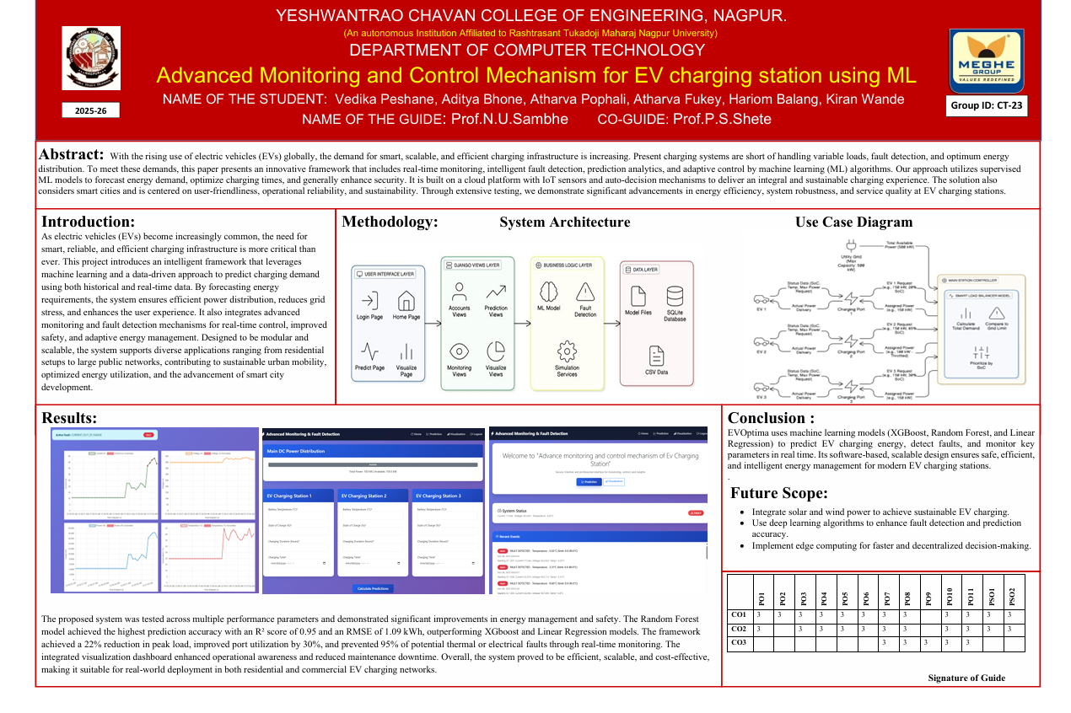

- Plagiarism report





- Resume
- Vedika Peshane



- Aditya Bhone

- Atharva Pophali


- Atharva Fukey


- Hariom Balang


- Kiran Wande


6.0 REFERENCES

- Ahmad Almaghrebi, Fares Aljuheshi, Mostafa Rafaie, Kevin James, Mahmoud Alahmad, "Data-Driven Charging Demand Prediction at Public Charging Stations Using Supervised Machine Learning Regression Methods," Energies, vol. 13, no. 16, pp. 1–18, 2020.
- Sanchari Deb, "Machine Learning for Solving Charging Infrastructure Planning: A Comprehensive Review," 2021 IEEE International Conference on Smart Grid and Smart Cities (ICSGSC), pp. 1–6, 2021.
- Abu Shufian, Nasif Hannan, Md Mukter Hossain Emon, Shaharier Kabir, Shaikh Anowarul Fattah, Md Sajid Hossain, "Automatic Fault Detection and Analysis of Electric Vehicle Charging Station by Machine Learning," 2024 IEEE Region 10 Symposium (TENSYMP),
pp. 1–6, 2024.
- Meiyi Huo, Songling Pang, Hao Bai, Wei Li, Min Xu, Tong Liu, "Data-Driven Short-Term Electric Vehicle Charging Station Demand Forecasting," 2024 IEEE Conference on Energy Internet and Energy System Integration (CIEEC), pp. 1–5, 2024.
- Arul Palaniappan, Purnima Bhukya, Sai Kiran Chitti, Jerry Gao, "Data-Driven Analysis of EV Energy Prediction and Planning of EV Charging Infrastructure," 2023 IEEE International Conference on Big Data Service and Applications (BigDataService), pp. 1–8, 2023.
- Prashanth Rajagopalan, Prakash Ranganathan, "Electric Vehicle Charging Behavior Prediction using Machine Learning Models," 2022 IEEE Electrical Power and Energy Conference (EPEC), pp. 1–5, 2022.
- Hareshma S, Sivraj P, "Design and Development of Smart Charging Infrastructure for Electric Vehicles," 2023 4th International Conference on Energy, Power and Environment: Towards Sustainable Growth (ICEFEET), pp. 1–6, 2023.

- Aakash Lilhore, Kavita Kiran Prasad, Vivek Agarwal, "Machine Learning-based Electric Vehicle User Behavior Prediction," 2023 IEEE Global Conference on Renewable Energy (GLOBCONHT), pp. 1–6, 2023.
- Milan Straka, Rui Carvalho, Gijs van der Poel, Ubo Buzna, "Analysis of Energy Consumption at Slow Charging Infrastructure for Electric Vehicles," IEEE Access, vol. 9,
pp. 49362–49374, 2021.
- Srinath M S, R Gunabalan, "Enhancement of Charging Efficiency of Batteries for Electric Vehicles—Review," 2022 International Conference on Electrical, Computer and Energy Technologies (ICECET), pp. 1–8, 2022.
- Mridul Shukla, Deepak Kumar Singh, Ashwani Yadav, Abhishek Kumar Singh, Nadia Adel Jumaa, Aymen Mohammed, "Optimizing Electric Vehicle Charging Station Placement in Urban Areas: A Data-Driven Approach," 2023 3rd International Conference on Computer Communication and Informatics (ICACITE), pp. 1–5, 2023.
- Fuli Qiao, Shan Lin, "Predicting Electrical Vehicle Charging Patterns at Public Charging Stations," 2024 International Conference on Big Data, Artificial Intelligence and Internet of Things Engineering (ICBAIE), pp. 1–8, 2024.
- Sakib Shahriar, A. R. Al-Ali, Ahmed H. Osman, Salam Dhou, Mais Nijim, "Machine Learning Approaches for EV Charging Behavior: A Review," IEEE Access, vol. 8, pp. 119553–119575, 2020.
- Ribal Atallah, Nassr Al-Dahabreh, Mohammad Ali Sayed, Khaled Sarieddine, Mohamed Elhattab, Maurice Khabbaz, Chadi Assi, "Quality of Service Evaluation and Forecast for EV Charging Based on Real-World Data," 2023 IEEE Wireless Communications and Networking Conference (WCNC), pp. 1–7, 2023.
- Vispi Nevile Karkaria, S B Abrish Aaditya, Ankur Karnadikar, P B Karandikar, Sarang Joshi, "EV Charging Infrastructure Development Using Machine Learning," 2023 International Conference on Emerging Computing and Automation (ICECA), pp. 1–6,

2023.
- Dhritiman Adhya, Ajoy Kumar Chakraborty, Arnab Pal, Aniruddha Bhattacharya, "Machine Learning Application for Prediction of EV Charging Demand for the Scenario of Agartala, India," 2022 IEEE International Conference on Electrical Power and Energy Systems (ICEPE), pp. 1–6, 2022.
- Marwa Chendeb EL Rai, Sabina Abdul Hadi, Haitham Abu Damis, Amjad Gawanmeh, "Prediction of Electric Vehicle Charging Stations Distribution Using Machine Learning," 2022 5th International Conference on Signal Processing and Information Security (ICSPIS),
pp. 1–6, 2022.
- Hengjie Li, Jianghao Zhu, Yun Zhou, Donghan Feng, Kaiyu Zhang, Bing Shen, "Review of Load Forecasting Methods for Electric Vehicle Charging Station," 2022 IEEE IAS Industrial and Commercial Power System Asia, pp. 1–8, 2022.
[19]K H Akhil, K Deepa, S.V. Tresa Sangeetha, N. Neelima, "Prediction of Battery Failure in EVs Using Machine Learning: A Case Study," 2024 International Conference on Knowledge Engineering and Communication Systems (ICKECS), pp. 1–7, 2024.
[20]K N B Sai Hitesh, P Saran Teja, J Ram Kumar, "Electric Vehicle Charging Demand Prediction using Machine Learning Algorithms," 2024 8th International Conference on Inventive Systems and Control (ICISC), pp. 1–7, 2024.

LIST OF PUBLICATIONS/ PATENT DETAILS

PATENT DETAILS

Sr.  No. | Name of Inventors | Title of Patent | Patent Applicatio n Number/  Status | Patent Office/ Country | Date of Publica tion
1. | SAMBHE, Nilesh Uttamrao SHETE, Pranay Sadashivrao  YENUKAR, Ganesh Keshavrao  PESHANE, Vedika Anil BHONE, Aditya Hemant POPHAL, Atharva Atul FUKEY, Atharva Satish BALANG, Hariom Ashok WANDE, Kiran Ramdas  TENDOLKAR, Vaishali  Dinesh | Advanced monitoring and control mechanism for electric vehicle charging station using Machine learning algorithm | 2025210909  73/ Patent Published | Indian Patent Office/ India | 10/10/20  25

CERTIFICATE OF PATENT PUBLICATION


